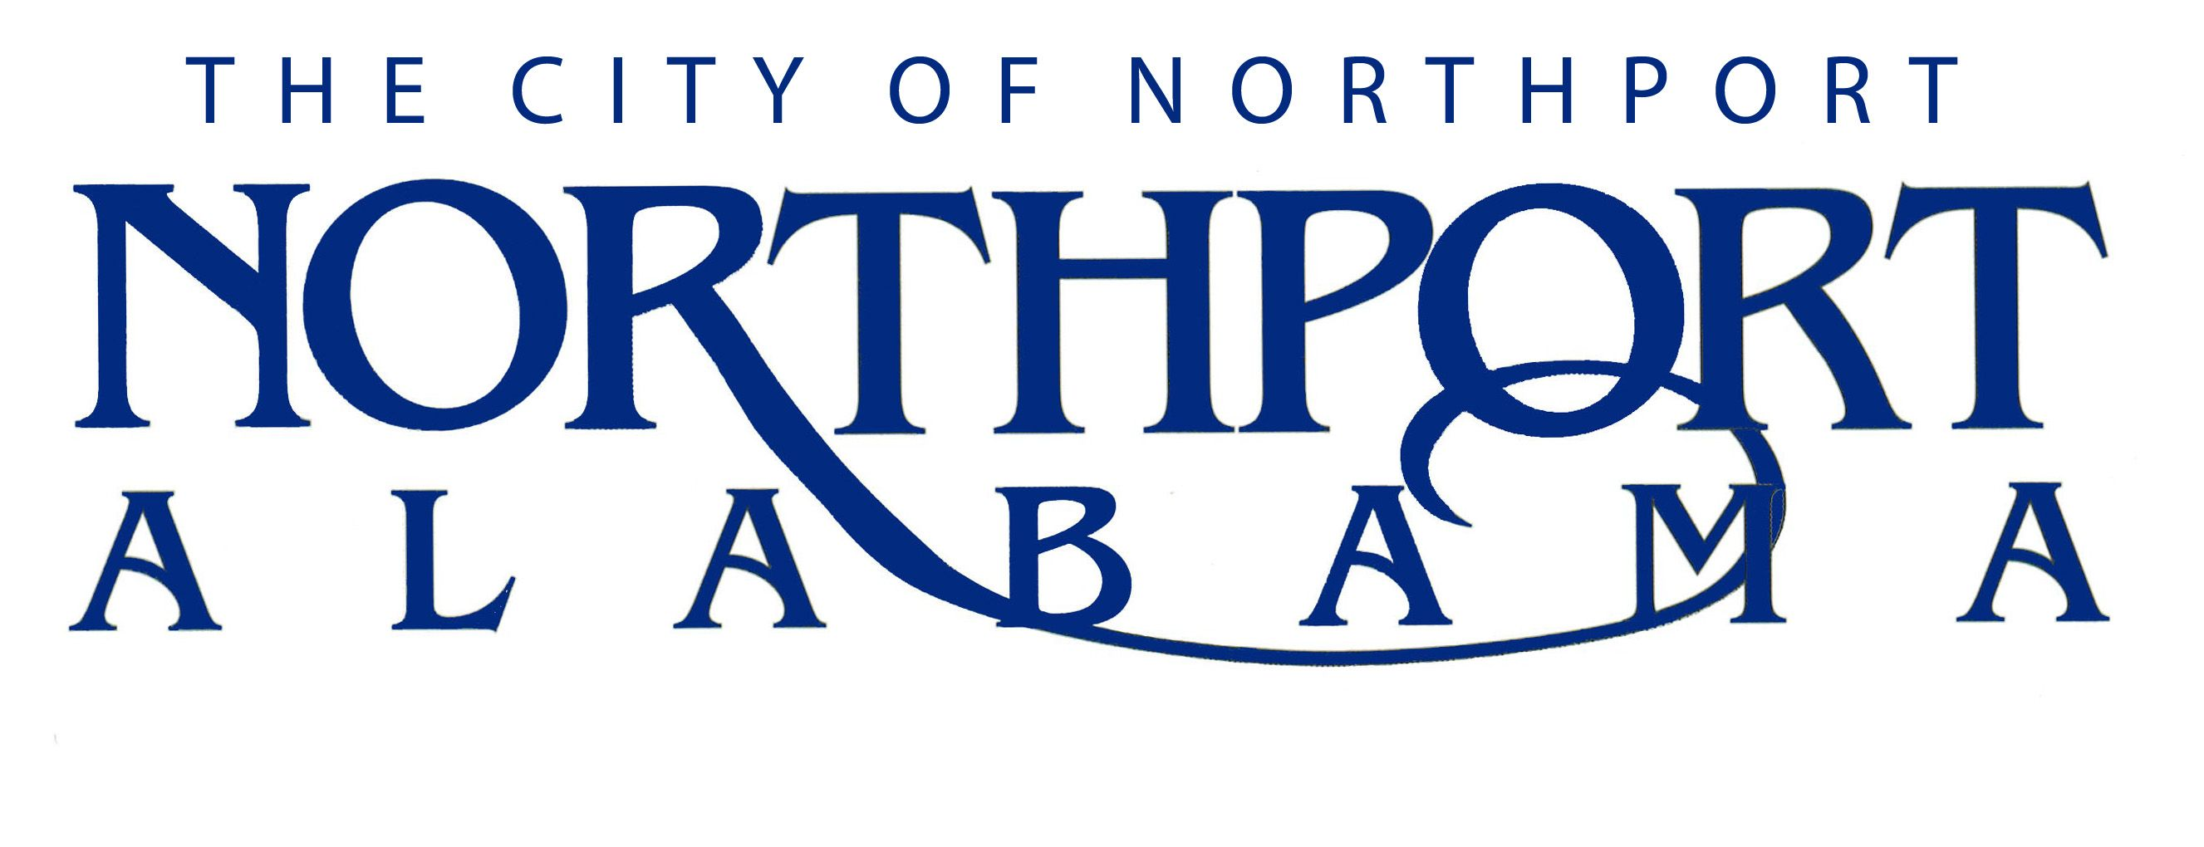
Assistant Director of Public Works

Summary

Assists in directing and coordinating activities of Public Works by performing the following duties personally or through subordinate supervisors.

DUTIES AND RESPONSIBILITIES

A. Essential Responsibilities

- Assists in directing and coordinating activities of the Public Works divisions such as maintenance, traffic, construction, garbage, trash, recycling, shop, and right-of-way.

- Assists in directing the administration of City policies as they relate to the department.

- Assists in directing all efforts to hear and address citizen complaints in respect to the department’s operations.

- Assists in directing all required maintenance and quarterly inspections of the Levee System and its drainage structures to include maintaining permanent inspection records as well as annual foot inspections with the United States Army Corp. of Engineers.

- Assists the Emergency Management Agency (EMA) and serves as the Department’s emergency preparedness coordinator during the absence of the Director.

- Assists in directing inventory control system and preventive maintenance programs.

- Assists in preparation of the annual departmental budget.

- Assists in locating, identifying and marking of graves at Williamson cemetery.

- Assists in directing Public Works improvement projects and quality control.

- Assists in the preparation of all vehicle, equipment, material, and construction specification requirement for the department.

- Assists in directing activities for collecting, evaluating, and submitting information for formal and informal bidding for material and equipment acquisitions.

- Attends all department head meetings, City Council pre-meeting, and City Council meetings in the absences of the Director.

- Authorizes or approves departmental expenditures in the absence of the Director.

- Assists in directing, planning, and implementation of the departmental training, including but not limited to safety, quality, performance enhancement and new employee orientation.

- Responsible for maintaining door security system and issuing fobs to employees.

B. Supervisory Responsibilities

- Assists Director in managing subordinate supervisors who supervise employees in Public Service. Is responsible for assisting in the overall direction, coordination, and evaluation of these units. Carries out supervisory responsibilities in accordance with the organization's policies and applicable laws. Responsibilities may include interviewing, orientation and training employees; planning, assigning, and directing work; appraising performance; rewarding and disciplining employees; addressing complaints and resolving problems.

C. Personal Competencies - To perform the job successfully, an individual should demonstrate the following competencies:
- Analytical - Collects and researches data; Uses intuition and experience to complement data.

- Design - Applies design principles; Demonstrates attention to detail.

- Problem Solving - Identifies and resolves problems in a timely manner; Works well in group problem solving situations; Uses reason even when dealing with emotional topics.

- Project Management - Coordinates projects; Communicates changes and progress; Completes projects on time and budget; Manages project team activities.

- Technical Skills - Strives to continuously build knowledge and skills; Shares expertise with others.

- Customer Service - Manages difficult or emotional customer situations; Responds promptly to customer needs; Responds to requests for service and assistance; Meets commitments.

- Interpersonal Skills - Focuses on solving conflict, not blaming; Maintains confidentiality; Keeps emotions under control.

- Oral Communication - Speaks clearly and persuasively in positive or negative situations; Responds well to questions.

- Written Communication - Writes clearly and informatively; Edits work for spelling and grammar; Presents numerical data effectively; Able to read and interpret written information.

- Teamwork - Balances team and individual responsibilities; Contributes to building a positive team spirit; Puts success of team above own interests; Able to build morale and group commitments to goals and objectives; Supports everyone's efforts to succeed.

- Visionary Leadership - Displays passion and optimism; Inspires respect and trust; mobilizes others to fulfill the vision; Provides vision and inspiration to peers and subordinates.

- Change Management - Communicates changes effectively; Builds commitment and overcomes resistance; Prepares and supports those affected by change; Monitors transition and evaluates results.

- Delegation - Sets expectations and monitors delegated activities; Provides recognition for results.

- Leadership - Exhibits confidence in self and others; Inspires and motivates others to perform well; Gives appropriate recognition to others.

- Managing People - Takes responsibility for subordinates' activities; Makes self-available to staff; Provides regular performance feedback; Develops subordinates' skills and encourages growth; Continually works to improve supervisory skills.

- Ethics - Treats people with respect; Keeps commitments; inspires the trust of others; Works with integrity and ethically; Upholds organizational values.

- Organizational Support - Follows policies and procedures; Completes administrative tasks correctly and on time; supports City’s goals and values.

- Judgment - Displays willingness to make decisions; Exhibits sound and accurate judgment; Supports and explains reasoning for decisions; Makes timely decisions.

- Motivation - Sets and achieves challenging goals; Demonstrates persistence and overcomes obstacles; Measures self against standard of excellence.

- Planning/Organizing - Prioritizes and plans work activities; Uses time efficiently; Organizes or schedules other people and their tasks.

- Professionalism - Approaches others in a tactful manner; Reacts well under pressure; Accepts responsibility for own actions; Follows through on commitments.

- Adaptability - Adapts to changes in the work environment; Able to deal with frequent change, delays, or unexpected events.

- Attendance/Punctuality - Is consistently at work and on time; Ensures work responsibilities are covered when absent; Arrives at meetings and appointments on time.

- Dependability - Follows instructions, responds to management direction; Takes responsibility for own actions; Commits to long hours of work when necessary to reach goals; Completes tasks on time or notifies appropriate person with an alternate plan.

- Initiative - Volunteers readily; Asks for and offers help when needed.

D. Performs all other reasonably related duties in a safe manner as assigned by the Director of Public Works.

JOB SPECIFICATIONS

Qualifications:

- Prefer a minimum of associate degree in business, a business-related field, and a minimum of three years related experience; or equivalent combination of education and experience.

- Must have a current driver’s license and must obtain a Class A CDL within one (1) year.

- Prefer a minimum of five years management/supervisory experience.

- Prefer a minimum of three years of field experience in the construction field, or equivalent field with a thorough understanding of the components of construction plans and practices; reading cut sheets, calculating and shooting grade, stationing and inspection of storm drainage features within newly constructed subdivisions.

Knowledge, Skills, and Abilities:

- Ability to read, analyze, and interpret general business periodicals, professional journals, technical procedures, or governmental regulations. Ability to write reports, business correspondence, and procedure manuals. Ability to effectively present information and respond to questions from groups of managers, clients, customers, and the general public.

- Ability to add, subtract, multiply, and divide in all units of measure, using whole numbers, common fractions, and decimals. Ability to compute rate, ratio, and percent and to draw and interpret bar graphs.

- Ability to solve practical problems and deal with a variety of concrete variables in situations where only limited standardization exists. Ability to interpret a variety of instructions furnished in written, oral, diagram, or schedule form.

- Must be proficient in Windows 10 and all aspects of Microsoft Office with a strength in Outlook, Word and Excel. Must be proficient on Adobe Acrobat X Standard to generate supporting maps and documentation.

Physical Characteristics:

- See well enough to read text on a computer terminal.

- Hear well enough to carry on a normal conversation with clients both in person and on the telephone.

- While performing the duties of this Job, the employee is regularly required to use hands to finger, handle, or feel; reach with hands and arms and talk or hear. The employee is frequently required to stand and walk. The employee is occasionally required to sit; climb or balance and stoop, kneel, crouch, or crawl. The employee must occasionally lift and/or move up to 50 pounds. Specific vision abilities required by this job include close vision, distance vision, color vision, peripheral vision, depth perception and ability to adjust focus.

- While performing the duties of this job, the employee is occasionally exposed to wet and/or humid conditions; moving mechanical parts; high, precarious places; fumes or airborne particles; toxic or caustic chemicals and outside weather conditions. The noise level in the work environment is usually quiet.

