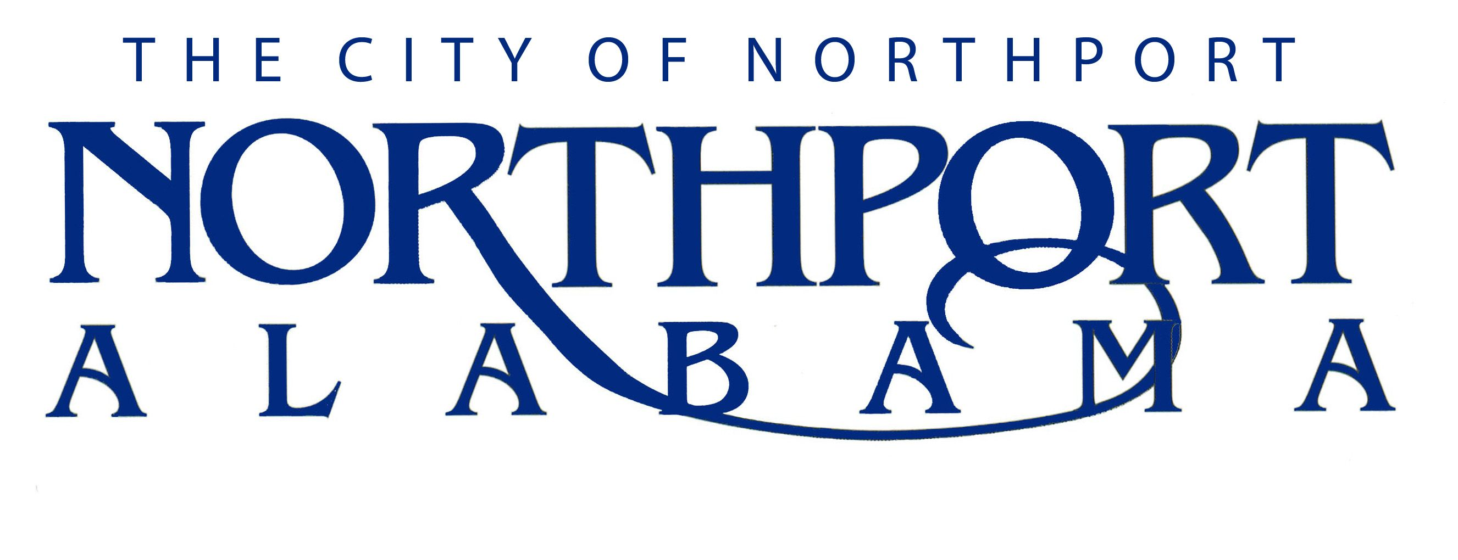
CONSTRUCTION CREW MEMBER

Summary:
Under direction, performs craft level and crew member duties in the installation, construction and maintenance of Public Works projects. Projects include: storm water systems, subsurface drains, storm drainage ways, bridge culverts, silt basins and roadways. Could be required to perform other duties in other departments within Public Works as assigned by the Director.
DUTIES AND RESPONSIBILITIES

A. Construction (30%)
- Assists in the construction and installation of equipment and material related to storm water systems.

- Assists in the construction and installation of equipment and material related to concrete flumes, sidewalks and curbs and gutters.

- Assists in the construction and installation of equipment and material related to subsurface drains including mix mortar and laying block and brick.

- Assists in the construction and installation of erosion control preventive measures for Public Works projects.

B. Maintenance (40%)
- Assists in the maintenance of the City’s storm drain system.

- Assists in the maintenance of the City’s subsurface storm drain system.

- Assists in the maintenance of erosion control devices on Public Works projects as needed.

- Assists in the maintenance of roadways, public right-of-way, sidewalks, curb and gutter and the levee flood gate maintenance program.

- Performs asphalt patch work as needed.
C. General Duties (30%)
- Landscapes as needed to complete public works projects to include laying sod, seeding, shrubbery, fill dirt and top soil and any other act needed to improve the appearance of a completed Public Works projects.

- Operates dump truck and asphalt truck as needed.

D. Performs other related duties in a safe manner as assigned by immediate supervisor and the director as required.

JOB SPECIFICATIONS
Qualifications:
- Must have an educational level equivalent to a high school diploma.

- Must have experience in the construction and maintenance of subsurface drainage, forming and finishing concrete structures, masonry skills.
- Must possess and maintain a valid Alabama commercial driver’s license (CDL), Class B, within six (6) months of employment.

- Must be able to work harmoniously with both citizens and employees of the City of Northport.

Knowledge, Skills, and Abilities:
- Knowledge of traffic laws, ordinances and rules involved in the operation of motor vehicles.

- Knowledge of the various materials, methods and practices and equipment used in the construction, maintenance and repair of storm water systems.

- Knowledge of the materials normally used and suitable for pipe cushion (bedding) and back fill; placement and compaction requirements.

- Knowledge to occupational hazards and applicable safety precautions in general construction and maintenance operations particularly as these requirements relate to work around construction equipment, trench excavations and traffic control around the work site (flagmen, signs, barricades and cones, etc.)

- Ability to meet the mechanical abilities of the job.

- Ability to use the technical terms normally associated with the construction and maintenance of Public Works such as cover, bedding, grade or slope, invert, lateral, survey stationing, etc.

- Ability to operate various types of equipment normally used in construction of Public Works projects including pipe and concrete saws, mechanical tamps, etc.

- Ability to comprehend and execute both written and oral instructions assigned to him/her for specific tasks or projects.

- Ability to accomplish the work assigned in an efficient, neat and dedicated manner.

- Ability to maintain an effective working relationship with other employees.

- Must maintain regular attendance on the job.

- Must be able to work overtime and on-call as required.

Physical Characteristics:
- Strength to perform heavy manual labor.

- See well enough to read text material and troubleshooting guides.

- Hear well enough to comprehend oral instructions in person and over the telephone/radio.

- Have ability to move and lift 100 pounds.

- Have ability to sufficiently move in and around confined spaces and rough terrain.

- Ability to work, year round, in all types of climatic conditions.

