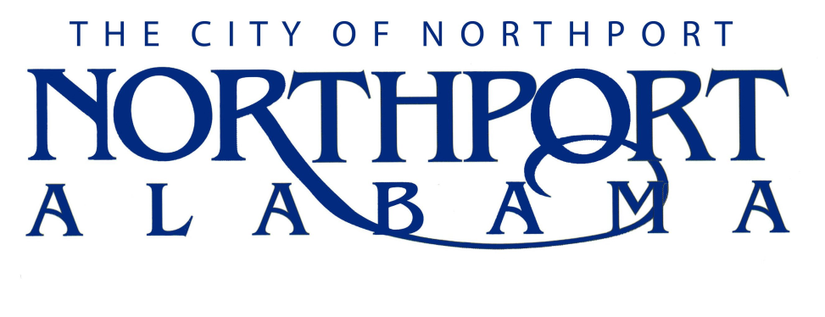
PLANNER I

Summary
Under the direction and supervision of the Director of Planning, this position performs a wide range of planning related duties including: Collecting data and writing reports, providing technical assistance to the Planning Commission, Zoning Board of Adjustment, Historic Preservation Commission, and to the public. Coordinating the development review process for plats, site plans, and other submissions to the department. May also perform other professional planning, administrative, and technical work in the accomplishment of a variety of planning functions, as well as other related duties as determined necessary and assigned by the Director.

TYPICAL DUTIES AND RESPONSIBILITIES

- Conducts review of applications and submissions including plats, permits, site plans, variance requests, and rezoning requests
- Responds to inquiries from the public regarding planning, zoning, and development activities, functions, requirements and procedures
- Writes and assembles staff reports
- Assists senior staff in the collection, compilation, and production of information, data, and graphics for use in planning and other related activities
- Assists with updates and maintenance of development regulations and ordinances
- Identifies problems, issues, and opportunities in the city that could be mitigated through better planning
- Attends City Council, Planning Commission, Zoning Board of Adjustment, and other meetings as needed, often held in evenings after regular work hours
- Provides assistance on a variety of subjects pertaining to planning, such as land use regulations, zoning ordinance, and subdivision regulations
- Assists the public and developers in the filing of applications for submission to the department, the City, or public bodies
- Meets with appropriate individuals and groups during the different aspects of a project as necessary
- Analyzes census and statistical data
- Prepares project summaries and status reports
- Attends various professional and job related meetings on behalf of, or as requested by the Director
- Assists in GIS/map data creation and maintenance, and map/plan file maintenance
- Attends seminars, conferences, and workshops relating to assigned projects and professional development; reviews publications and reports to keep abreast of programs and policies pertinent to the department and the planning field

- Performs other reasonably related duties in a safe manner as assigned by the Director

JOB SPECIFICATIONS

Minimum Qualifications:

- Bachelor’s degree in Urban Planning, Geography, Engineering or closely related field preferred; or three years experience in municipal planning or related field; or any equivalent combination of training and/or experience that provides the required knowledge, skill and abilities for this job;
- Must possess a valid driver’s license

Knowledge, Skills, and Abilities:
- Well-developed knowledge of planning principles and practices
- Knowledge of public administration practices and governmental activities
- Working knowledge of land use regulations and comprehensive planning processes
- Working knowledge of computer applications including Microsoft Word, PowerPoint, and Excel
- Familiarity with GIS applications
- Skills to analyze data using basic quantitative methods
- Skills in writing to compose business letters, reports, and grant proposals
- Possess organizational skills to develop project proposals and to satisfy project record-keeping requirements
- Possess communication skills sufficient to speak before groups of people to explain project proposals and to convey project findings and recommendations
- Possess reading skills to identify and comprehend pertinent information; to understand instructions, regulations, guidelines, policies, and procedures
- Ability to work independently without close supervision or in a team environment as needed
- Ability to research a subject thoroughly
- Ability to meet project deadlines
- Ability to work concurrently on several projects in various stages of completion
- Ability to maintain regular attendance on the job
- Ability to maintain an effective working relationship with citizens, developers, engineers, and other professionals and co-workers
- Ability to attend to details while keeping big-picture goals in mind
- Must be willing to travel out of town/state and locally as required
- Must be able to attend night meetings
- Must be willing to comply with dress code and standards

Physical Requirements:
- See well enough to read fine print and numbers without error or transposition
- Hear well enough to carry on a normal conversation in person and by telephone
- Effectively operate a keyboard, computer, copier, and other office machines
- Have ability to move and lift and move records, files, and boxes weighing no more than 25 pounds
- Have the physical ability to get into and out of, and operate a motorized vehicle

