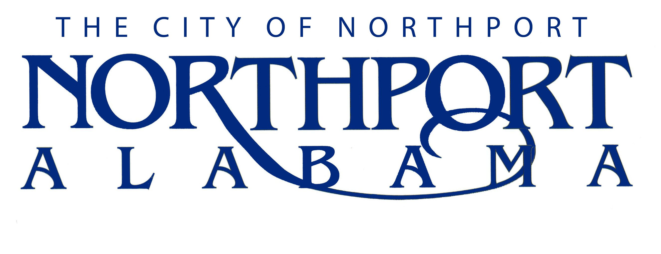

WASTEWATER TREATMENT PLANT OPERATOR TRAINEE

Summary

Under immediate supervision, performs wastewater treatment plant operation duties of an introductory nature. The duties in this position are designed to introduce the individual into higher level wastewater operation careers in the wastewater treatment plant. An employee initially works under the direct supervision, which acquaints the trainee with the work and its relationship to other departments. After a period of orientation and on-the-job training, the employee is assigned as an operator or system maintenance person with duties becoming more difficult and supervision becoming less direct, while moving through the certification process. The employee reports directly to the Wastewater Treatment Plant Superintendent.

DUTIES AND RESPONSIBILITIES

A. Treatment Plant Operation (70%)

- Ensures proper dosages of chemicals and mixing operations, tank elevations, filter processes, laboratory work, safety, drying bed maintenance, operational data logs and compliance with all local, state and federal regulations.

B. Equipment Repair and Maintenance (20%)

- Follows preventive maintenance schedules for all equipment.

- Performs repairs and replacement of defective parts and equipment.

- Inspects equipment and machinery according to procedures and requests necessary supplies, equipment and repair parts.

C. Sampling and Testing (5%)

- Performs required analytical testing for the treatment facility assigned. Records and reports all data.

- Collects required bacteriological, primary and secondary, testing samples.

- Follows and updates Standard Operating Procedures.

D. General Duties (5%)

- Greets the general public.

- Receives and attends to customer complaints.

- Prepares for required certification examination by studying appropriate materials.

E. Performs all other reasonably related duties in a safe manner as assigned by immediate supervisor or other supervisor as required.

JOB SPECIFICATIONS

Qualifications:

- Must have an educational level equivalent to high school graduation. College coursework desired.

- Must pass the certification exams listed below by the required deadline, or be subject to termination:

- Alabama Grade II Wastewater certification exam as required by ADEM within a four (4) month period from the date of hire.

- Alabama Grade IV Wastewater certification exam as required by ADEM within a twelve (12) month period from the date of hire.

- Must hold a valid driver’s license and have an acceptable driving record.

- Must obtain a Class B Alabama Commercial Driver’s License within 9 months of hire.

Knowledge, Skills, and Abilities:

- Some knowledge of the principles and practices used in water treatment.

- General knowledge of mathematics and science.

- Verbal communication skill to communicate clearly and distinctly in person or by telephone.

- Reading skill to follow written instructions, interpret gauges, charts and troubleshooting guides.

- Skill to use diagnostic equipment on pumps, controls, motors, and electrical systems.

- Skill to repair pumps, motors, controls and electrical systems.

- Ability to obtain wastewater treatment certification within required time period.

- Ability to learn to operate equipment necessary for drying bed maintenance.

- Writing skills to clearly and concisely correspond with businesses and supervisors.

- Ability to write legibly.

- Ability to maintain effective working relationships with other employees and the public.

Physical Characteristics:

- See well enough to detect audible alarms and warning devices.

- Hear well enough to detect audible alarms and warning devices.

- Hear well and speak clearly enough to carry on a verbal conversation.

- Hear and speak clearly enough to use a telephone or linc.

- Physical agility to move freely on ladders, stairways, and in confined spaces.

- Physical ability to work in various climatic conditions and move equipment and machinery weighing no more than 100 pounds.

