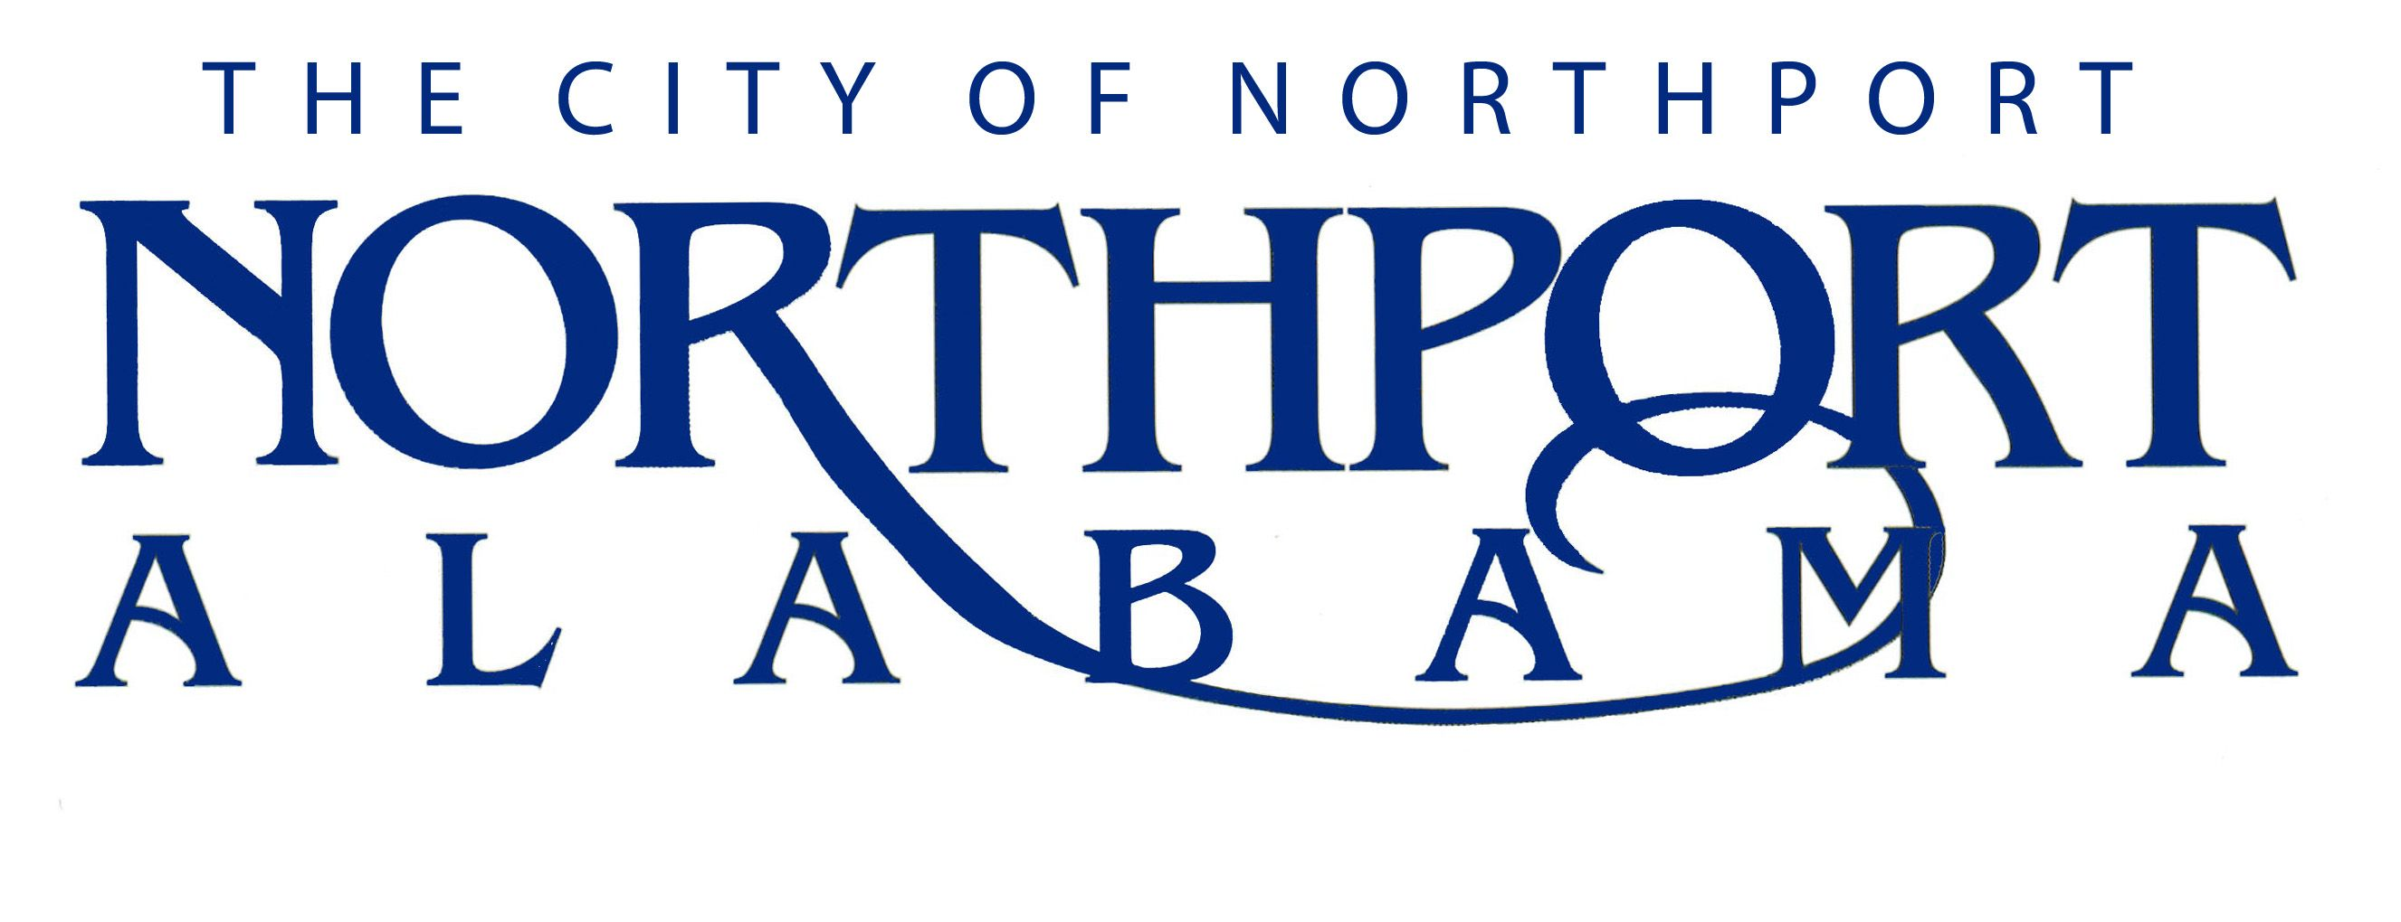
POLICE OFFICER

Summary:
Under immediate supervision, protects persons and property. Works in accordance with departmental rules and regulations to receive assignments and instructions from police personnel of higher rank. Duty involves an element of danger and is performed in all types of weather.

DUTIES AND RESPONSIBILITIES

A. Patrol (50%)
Patrols in an assigned area. Answers calls to determine if criminal activity has occurred and assists in making arrests.

B. Detection/Assistance (40%)
Becomes familiar with the people and physical details of assigned areas to enhance detection of unusual activities.
Assists at the scene of a crime/accident, assists in administering first aid, locates witnesses and obtains witness statements and makes arrests; testifies as a witness in court proceedings.

C. Training (10%)
Receives extensive training in the investigation of traffic accidents, traffic control and report writing. Trains periodically on job related subjects. Other training deemed necessary will be provided.

Performs other duties as assigned by immediate supervisor and other supervisors in a safe manner as required.

JOB SPECIFICATIONS

Qualifications:
- Must have an educational level equivalent to high school graduation.
- Must be at least 21 years of age.
- Must possess a valid driver’s license and have an acceptable driving record.
- Must never have been convicted of a crime of moral turpitude or misdemeanor involving the use of force or violence.
- Will be required to pass the Civil Service Board’s written examination, The Alabama Peace Officer Standards Training Course, a pre-employment physical and drug screen, and a psychological evaluation.
*If an applicant is currently APOST certified and currently employed by another law enforcement agency in the State of Alabama, they will be allowed to forego the written examination and APOST Physical Training Requirements. The applicant still must pass all other pre-employment checks.

Knowledge, Skills and Abilities:
- Working knowledge of State and Federal laws and City ordinances.
- Knowledge of the behavioral traits that are needed to remain impartial and objective in dealing with the public.
- Knowledge of the general layout of the City of Northport.
- Good interpersonal skills in dealing with the public and often time in less than ideal conditions.
- Ability to develop skill in the use of firearms.
- Skill to safely operate an automobile at various speeds in all types of weather conditions.
- Verbal communication skills to clearly and distinctly communicate by radio.
- Writing skills to effectively complete reports in a clear and concise manner.
- Ability to successfully complete the mandatory 480 hour Alabama Law Enforcement Academy.
- Ability to comprehend and execute verbal and written instructions
- Ability to work in all types of weather.
- Ability to learn and perform CPR and basic first aid.
- Ability to maintain an effective working relationship with other employees.
- Must maintain regular attendance on the job.

Physical Characteristics:
- See well enough to operate a firearm safely and accurately.
- See well enough to read small print on driver’s licenses.
- Hear well enough to answer radio transmissions.
- Hear well enough to carry on normal conversations.
- Effectively operate a motor vehicle, firearm, radio, and other police equipment.
- Have the ability to move quickly in emergency situations.
- Physical abilities to exercise self-defense techniques.
- All other Police Officer Standards Training Commission requirements must be met.
- Strength to lift, drag and carry other officers, victims, and suspects out of emergency situations.

